

**DEPARTMENT OF COMPUTER SCIENCE**

**AND APPLICATIONS**

**IBM PROJECT REPORT**

**HR DATA ,INCLUDING EMPOLYEE INFORMATION**

*Submitted by*

*S.DHARANI(222312123)*

*S.DARSHITHA(222312122)*

*P.MARIYA ANISHA (222312125)*

**BACHELOR OF SCIENCE IN COMPUTER**

**SCIENCE WITH ARTIFICIAL INTELLIGENCE**

*Under the guidance of*

*SUBHA SRI. S- Corporate Trainer*

**2023 - 2024**

**DECLARATION**

We, **Dharani,darshitha,mariya Anisha. A** hereby declare that this project report on **“**HR Data ,Including employee Information Data using COGNOS tool” submitted to University of Madras in partial fulfilment of the requirement for the award of the Degree Bachelor of computer science with Artificial Intelligence under the guidance of **DR.G.MONIKA M.Sc., PhD., HEAD OF DEPARTMENT** and **SUBHA SRI. S** has not been submitted earlier to any other university or institute for the award of any degree.

**S.Dharani**

**S.Darshitha**

**P.Mariya Anisha**

**Place:**

**Date:**

**BONAFIDE CERTIFICATE**

This is to certify that the project titled “HR Data, Including Employee information data using COGNOS tool”is the bonafide work done by , **Dharani,Darshitha,Mariya Anisha** here by and first year student of Jeppiaar College of Arts and Science , Padur, Chennai in partial fulfilment of the requirment for the award of the Degree of Bachelor of computer Science with Artificial Intelligence 2023-2024.

**PROJECT GUIDE:SUBHA SRI. S**

**HEAD OF THE DEPARTMENT:**

**Date:**

|  |  |  |
| --- | --- | --- |
| **S.No** | **INDEX** | **Page No** |
| 1. | INTRODUCTION |  |
| 2. | ABSTRACT |  |
| 3. | REPORTS  1.Experience in current domain city colored by education  2.According to there Experience and joining of year leave or not  3.Age and gender colored by city sized |  |
| 4. | FINNAL DASH BOARD |  |
| 5. | CONCLUTION |  |
| 6. | REFERENCE |  |

**INTRODUCTION:**

This project explains as The HR data ,and the Employee information in this we have gave the report about there education ,there experience, there gender ,there age ,and about the salary according to there experience and leave it mean through there attendance the salary will be given, we have collected this data set from side to side kaggle and we have used COGNOS to create a dashboard.

**ABSTRACT:**

This project explores the utilization of IBM COGNOS Analytics for analyzing The HR data,Including Empolyee Informatin COGNOS' versatile List,Crosstab Dashboard,Locationwe have created a chart according to Reports we delve into data exploration and analysis. Through uncovering trends and patterns, actionable insights are extracted to drive informed decision-making. Join us on this journey as we showcase the power of COGNOS in unlocking the potential for strategic decision-making and operational excellence in hotel management.

**List For HR Data Including Employee Information:**

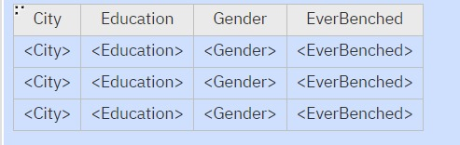

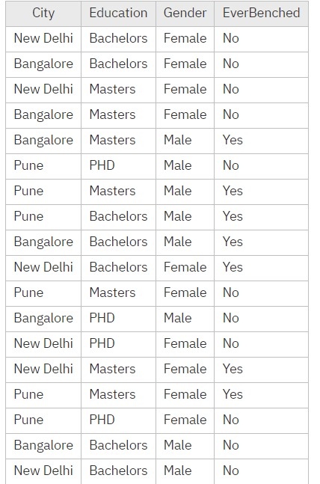

**CrossTab:**

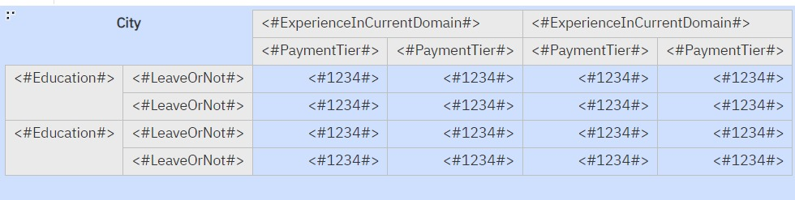

**Output:**



**Dashboard**

Top of Form

1.Experience in current domain by city colored by education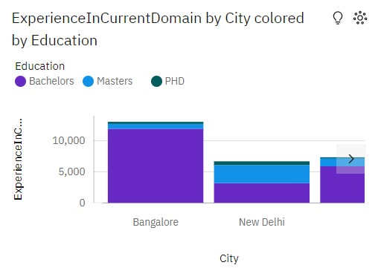

2.According to there experience and joining year Leave or Not

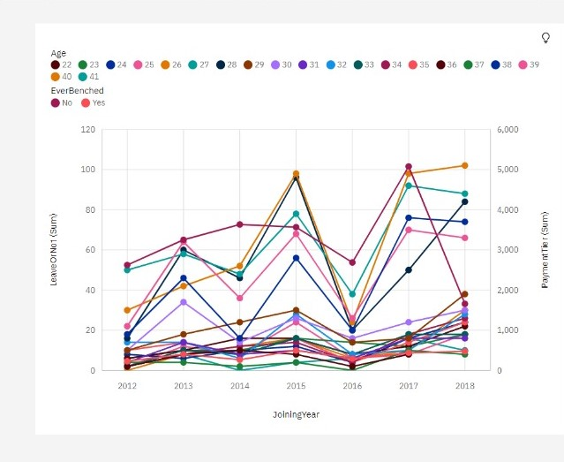

**Final Dashboard:**

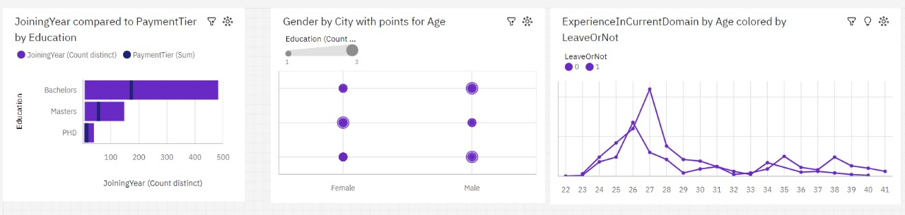

**Location:**

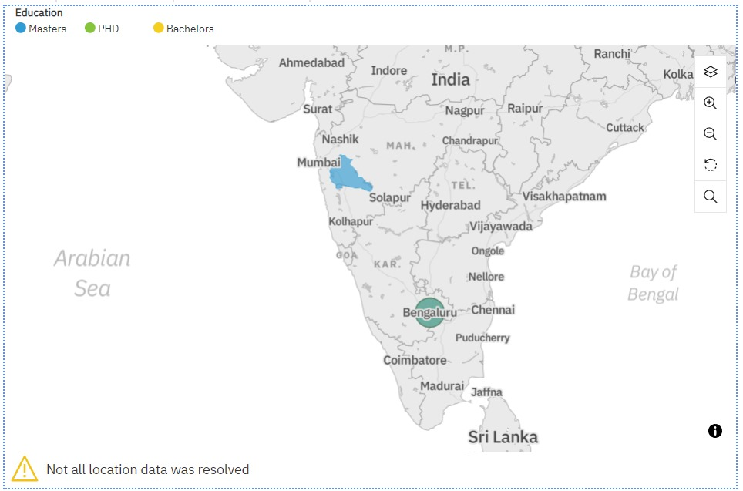

**CONCLUTION:**

Our project has used IBM COGNOS Analytics to study HR data ,Including employee information. We've explored by list,crosstab dashboard,Location of the data using tool visualizations. By doing this, we've found The experience of the employee and age ,gender and etc,

Our work is just the beginning. We'll keep using COGNOS Analytics to find various information about HR

**REFERENCE:**

https://ap1.ca.analytics.ibm.com/bi/?perspective=dashboard&pathRef=.my_folders%2FHR&action=view&mode=dashboard&subView=model0000018f0be1473d_00000000

https://github.com/Dharani-Darshi-Ani/Project-HR.git